

SurveilStar Professional Software
User’s Manual

Latest updated: March 1, 2011

http://www.surveilstar.com

Table of Contents
(Tips: Clicking the following title can take you to the topic quickly. You can press the keyboard buttons “Ctrl + F” to search this document.)
- Welcome to SurveilStar Professional………………………………3
1.1 Main Widow
1.2 Features
1.3 Basic Structure
- Installation……………………………………………………………….8
  - Requirements
  - Installation
  - Un-installation
- Monitor and Controlling……………………………………………..12
3.1 Monitoring
3.1.1 Monitor Screen Snapshot
3.1.2 Monitor Email
3.1.3 Monitor Chat/IM Activity
3.1.4 Monitor Website Visited
3.2 Control Setting
3.2.1 Set Screenshot Interval
3.2.2 Block Specific Website
3.2.3 Control Chat/App Usage
- Other Setting……………………………………………………………24
  - Account Setting
  - Language Setting
- Purchase and Register………………………………………………..26
  - Purchase
  - Register
- Support…………………………………………………………………..29
  - FAQs
  - Contact Us
1. Welcome to SurveilStar Professional
SurveilStar Professional is a trustworthy PC/Internet web-based monitoring software to safeguard your children's online safety by monitoring kids online activity, grabbing screenshots, recording email, IM chats and websites visited history.

* Protect children from cyber bullying, porn, inappropriate web contents, etc.
* Increase time on task for children
* Prevent children from meet an online friend in person
* Reduce children's time spent on online games or social networking sites

Download SurveilStar Professional at http://www.surveilstar.com/download.html
Contact us at support@surveilstar.com

  - Main Window
The main window of SurveilStar Professional is illustrated as follows:
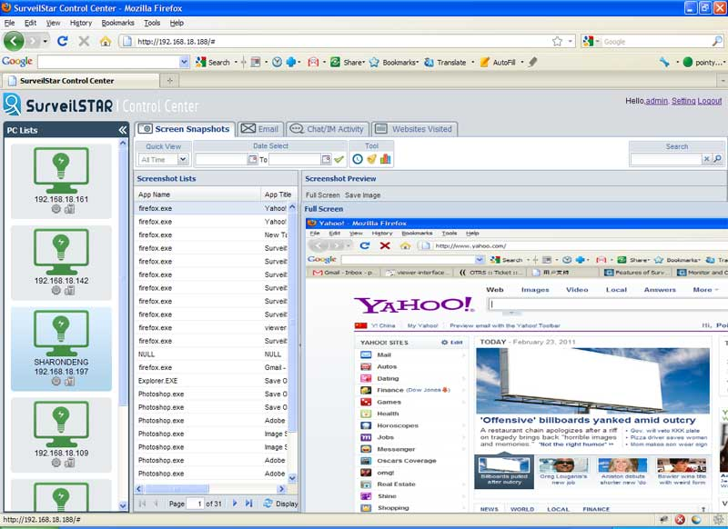
The main window of the program is divided into 3 parts:
(1) PC Lists: list all the monitored computer. Here, you could easily set screenshot interval setting, Filter websites based on URL and keywords, block websites or web site categories during specified time range, block the usage of inappropriate applications or application categories during specified time range, etc. Besides, you can uninstall the computer server which you don't want to monitor any more from this panel.
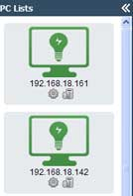

- Tool buttons: You can view real-time screenshots, monitor Email sent and received, IM chats and websites visited. You can search recorded history by setting start time and end time, view the statistic chat on top 10 websites visited, application usage, etc.
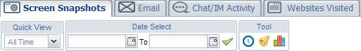

- Recorded history lists: including Screenshot lists, Email lists, Chat lists and Web surfing history. Record all the information of computer activity like URLs, captions, users, Email subject, etc. You can view the detailed information like full screenshot of websites visited, IM chats, emails, etc. in the right panel.
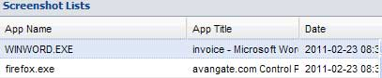
  - Features
With SurveilStar Professional Software, you can monitor Kids online activity, grabbing screenshots, recording email, IM chats and website history, filter websites to protect children's online safety.

Screen Monitoring
* Take real-time screen snapshot
* Remotely watch your children's computers like a television
* Monitor multi-computer screens at one time
* Set different screen recording Intervals
* View agent computer screen history
* Search snapshot history by date (begin/end), Name or IP address
* Save snapshot as *.png image formats

Email Monitoring
* Record incoming and outgoing SMTP/POP3 emails and Exchange emails
* Record outgoing webmails and Lotus Notes emails
* Record all contents of outgoing and incoming attachments
* Record email subjects, senders, recipients, time, size, etc.
* Specify expiring time to control the life cycle of the saved email correspondence

IM Monitoring
* Support monitoring over ten popular IM applications which are MSN Messenger, Skype, ICQ, Yahoo! Messenger, Lotus Sametime, Tencent QQ, etc.
* Record sent and received instant messages
* Record the duration of IM chatting, local user and participants.
* Block IM chats with specific application names
* Search recorded instant messages by date (begin/end), Name

Website Monitoring
* Record all the visited websites, URLs, captions, users, and computers to estimate users’ browsing activity
* Record logs of web surfing history
* Provide top 10 visited websites report for administrators
* Generate accurate website visited statistics
* Filter websites based on URL and keywords, block users from visiting malicious, inappropriate websites or website categories during specified time range
* Custom website categories according to your management needs
* Create unique website classes for each agent

Application Monitoring
* Log comprehensive application activity
* Collect statistics on application usage
* Limit the usage of inappropriate applications with application name
* Block the usage of inappropriate applications or application categories during specified time range
* Class applications into different categories

  - Basic Structure
SurveilStar Professional is comprised of Server, Control Center and Agent. Agent is installed on the computers you need to monitor, and server will invisibly collect all the data from the agent computers, and users can monitor all Internet activities of monitored computers in control center.

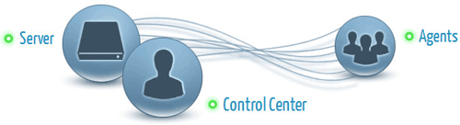
SurveilStar Professional Agent can
* Collect data of monitored computer/user's PC/Internet activities
* Send collect data to server
* Execute commands from server
* Capture and send screen snapshots to console in real-time
* Run in stealth mode
* Self-protect from unauthorized uninstalling
SurveilStar Professional Server can
* Collect and store the data from monitored computers periodically
* Execute control strategies
* Backup and manage log history
* Manage all monitored computers
SurveilStar Professional Control Center can
* Watch real-time screen snapshots of monitored computers
* Review all computer/Internet activities of monitored computers/users
* Choose computers/users to be monitored
* Setup strategies on controlling monitored computers/users

2. Installation

2.1 Requirements

Server and Controller System Requirement
OS: Win2000 SP4/2003 SP1/XP SP2/Vista/Win 7
Available Hard Disk Space: 10 GB - 50 GB, or more
RAM: > 512 MB

Agent System Requirement
OS: Win Me/NT4/2000/2003/XP/Vista/Win 7
Available Hard Disk Space: 100 MB, or more
RAM: > 128 MB

Supported Web Browsers
IE, Firefox, Chrome, Safari, Opera and many more browsers.

2.2 Installation

(1). Install SurveilStar Agent, Server and Controller on Single Machine
If you want to monitor and record your computer activity while you are away, you can install SurveilStar Agent and SurveilStar Server and Controller on a single machine. SurveilStar Professional provides you the ability to password protect your web traffic statistics to ensure that only authorized people have access to SurveilStar Control Center. In this case, just parents can learn and control what their kids are doing online.

First, please download SurveilStar Professional SurveilStar Pro setup file, then double click SurveilStar Pro Setup.exe and select the language to use during the installation. There are five languages available for your choice: English, French, German and Japanese, Chinese.

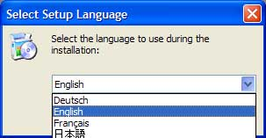
Second, please choose both "SurveilStar Agent" and "SurveilStar Server and Controller" when prompted to select components. When the installation is finished, you could monitor and control all the computer activity in a single computer.

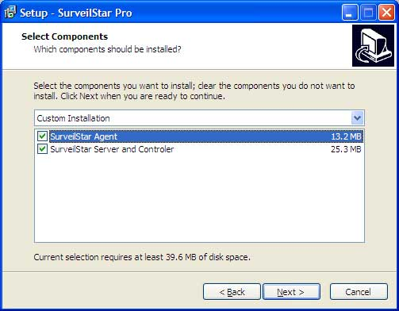

(2). Install SurveilStar Agent, Server and Controller on Separated Machines
(A). Installing SurveilStar Professional Server and Controller

First you need to install SurveilStar Any Parental Control, you can download SurveilStar Pro setup file from our web site. The server can be deployed on a dedicated computer or any computer deemed appropriate to be used as a data server.

Please double click SurveilStar Pro Setup.exe, select the language, then choose SurveilStar Server and Controller when prompted to select components. Please notice that SurveilStar Server should be installed in the computer with which you want to monitor other computers.
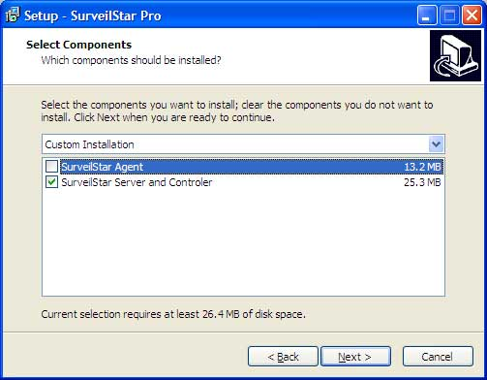

(B). Installing SurveilStar Professional Agent

SurveilStar Professional Agent should be deployed to computers that are required to be monitored and controlled. Please download or copy SurveilStar Professional setup file in the computer you want to monitor to install SurveilStar Agent.
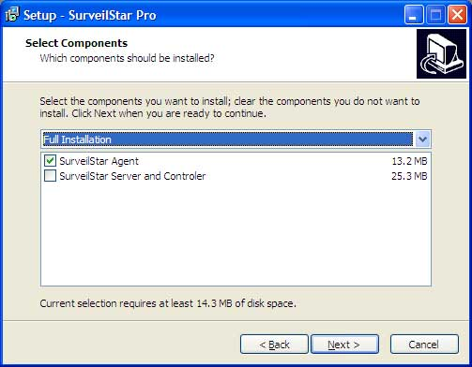
Note: Please reboot the computer when the installation is completed.

2.3 Un-installation

Note: If you want to remove the entire SurveilStar PC/Internet monitoring system, including Agents, Server and Controller, please delete all SurveilStar Agents first. Otherwise, the deployed SurveilStar Agents will continue to run in those computers, even though the SurveilStar Server is removed.
(1). Un-installing SurveilStar Agents from Server and Controller
Login to the SurveilStar Server and Controller, click the uninstall button under any selected computer in the PC lists.

Then a alert info box pop-ups and click Yes.(as shown bellow).

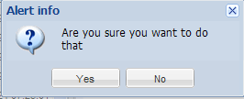

(2). Un-installing SurveilStar Server and Controller
On the desktop of Windows system, click "Start > All Programs > SurveilStar Pro> Uninstall SurveilStar Pro", or go to "Control Panel > Add/Remove Program" to uninstall SurveilStar Server and Controller.
3. Monitoring and Controlling

3.1 Monitoring

After installing SurveilStar Agent, Server and Controller successfully, you can start monitoring and controlling your kids online activities, such as emails, IM chats and website visited.
Login SurveilStar Control Center by clicking Start > All Programs > SurveilStar Pro > SurveilStar Pro Control Panel

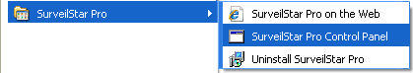

Enter the Username and Password, then press Submit button to open SurveilStar Control Center:

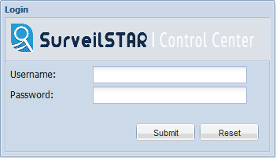

On the SurveilStar Control Center, you can take screen snapshots, record emails, monitor IM chats, and website visited; besides, you can set screen snapshot interval, block specific website, and control IM/App usage.

3.1.1 Monitoring Screen Snapshot

SurveilStar Professional Software takes snapshots of whatever is on the computer screen. Snapshots can be taken as frequently as once a second, or they may be taken based on specified frequency.

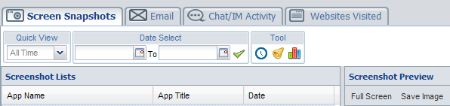

(1). Search screen snapshot history
To view the screen snapshot history of any specified computer/user, please select a computer/user, click the Screen Snapshots tab, select the date, then you can see the screen snapshots in Screenshot Lists and Screenshot Preview.
You can also view the history in video-like mode by clicking History Playback of the Tool sub-tab.

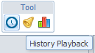

(2). Real-time monitoring
To view the screen of any computer/user in real-time, please select a computer/user, click the Screen Snapshots tab and then click Realtime of the Tool sub-tab.

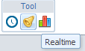
(3). Save screen snapshot as images
You can also save selected screen snapshot history in PNG image format. Just click the menu "Save Image" in Screenshot Preview window.
Tip: You can set the interval time for capturing screen snapshot in control center.

3.1.2 Monitoring Email

SurveilStar Professional records and stores all the information you'll need - whether an email was sent or received, who sent it, who received it, the date and time an email was sent or received, the subject, the contents and any attachment.

Each email record includes:
* Subject
* Sender
* Recipients
* Date
* Content
* Attachments (if any)

Select a computer/user, a group, or the whole network, and then click Email, and you will see the email records.

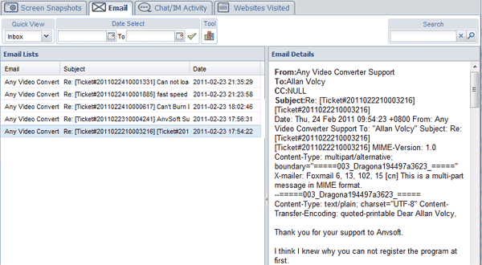

SurveilStar Professional automatically saves a copy of every email sent or received. Even when the email was deleted, SurveilStar will keep a copy for you to review. Select a computer/user, a group, or the whole network, you can search email records by email's title.
You can also check the specific recorded email by using Quick View and Date Select function. You can also review the Statistic Chart of the recorded emails by clicking Tool.

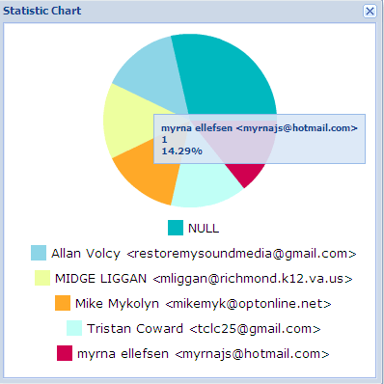

3.1.3 Monitor Chat/IM Activity

With the Chat/Instant Message recorder built into SurveilStar Any Parental Control, chat conversations and instant messages are automatically recorded and saved for your later review. SurveilStar Professional is also compatible with all major instant messaging software. It is not only able to log outgoing messages by a local user, but also incoming messages too. It records both sides of a conversation allowing you to see what your employees are saying as well as how other chat participants respond.

SurveilStar Professional supports the following chats/IM applications:
* ICQ
* Yahoo! Messenger
* MSN Messenger
* Google Talk
* Skype
* Tencent QQ
Select a computer/user, a group, or the whole network, and then click Chat/IM Activity, and you will see the Instant Message records.

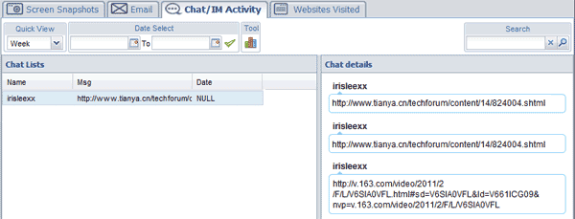
You can also check the recorded instant message by using Quick View and Date Select function.
Click the Tool button, and you will be prompted the following pie chart which shows the top 10 statistics.

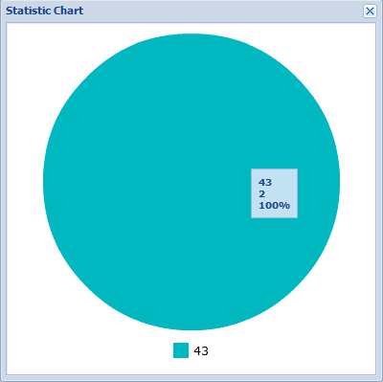
You can also control Chat/IM Activity by customizing Chat/App Setting in control center.

3.1.4 Monitor Website Visited

Google, Yahoo, MySpace, Facebook, YouTube … Whatever website they visit, SurveilStar Professional Software keeps a detailed record of who, when, what, how long and how often they browse the Internet.

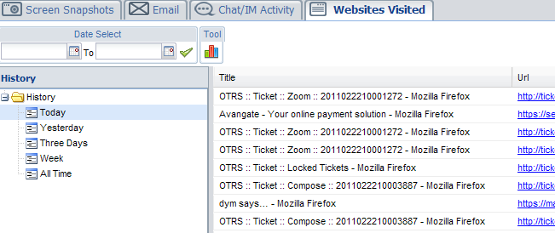

To view the websites visited history of any specified computer/user, please select a computer/user, click the Websites Visited tab, go to the left pane and select the date, then you can see the websites visited history with Title, URL and Date.

Just click the Tool button on the main interface, then a statistic pie chart will pop up, which shows the top ten most frequently visited websites.

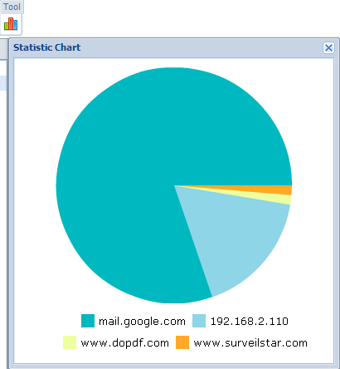

Tip: You can filter or block specific websites by adding URLs to the website library in the control center.

3.2 Control Setting

SurveilStar Professional allows administrator to customize the control settings of monitored computers in Control Center.
In the left pane, administrator can choose the monitored computer in PC Lists, and then click button.
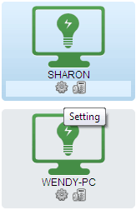
Then it will pop up a new window like the following:

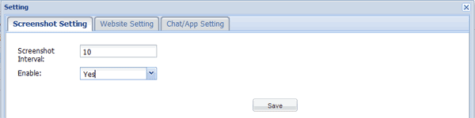

Screenshot Setting
Website Setting
Chat Application Setting

3.2.1 Set Screenshot Interval

You can set the interval time for capturing screen snapshot. The default interval time is 10 seconds. That means SurveilStar will take one snapshot every 10 seconds. The valid interval time range is 1s to 999s.

3.2.2 Block Specific Website

SurveilStar Professional Software could filter and block the specific websites. It allows administrators to customize website setting in control center.

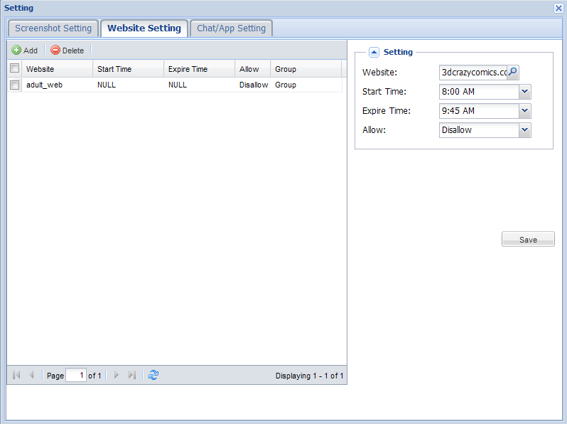

In the right pane, administrators could input the website URL manually in Website, such as www.porn.com. In addition, administrators can also select the websites from the library by clicking button. In the library, administrators could not only add the URLs directly but also add the URLs into a group and select them by group.

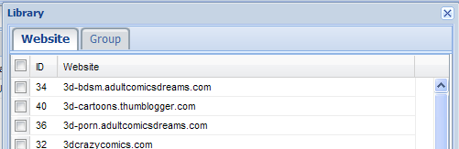

Then choose the Start Time and Expire Time. It allows you to set the time duration for the action.
Next select Allow/Disallow. If choose Allow, it means SurveilStar Professional will block and filter the websites at the duration you set; if choose Disallow, it means the control center will not block and filter the websites at that duration.

3.2.3 Control Chat/App Usage

SurveilStar Professional records all instant messages sent and received by popular instant messengers, e.g. MSN/Live Messenger, Yahoo Messenger, Skype, ICQ, etc. It also allows parents to customize chat/application setting in control center.
Select a computer/user, a group, or the whole network in the left PC Lists, and then click button. Then it will pop up the control setting window, you can choose Chat/App Setting

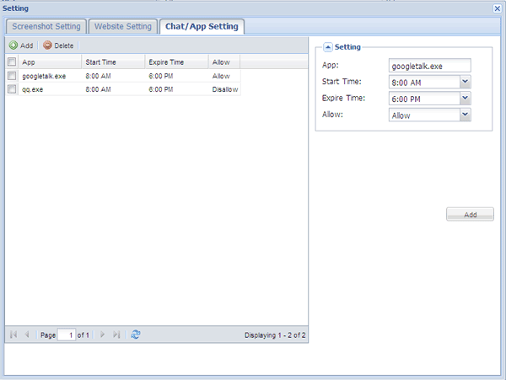

In the right pane, administrators need to input the name of process manually in App, such as googletalk.exe, then choose the Start Time and Expire Time. If choose Allow, it means SurveilStar Professional will monitor this application at the duration you set; if choose Disallow, it means the control center will not record and monitor this application at that duration.

4. Other Setting
4.1 Account Setting

SurveilStar Professional provides parents the ability to set password to protect web traffic statistics to ensure that only authorized people have access to SurveilStar Control Center. Here the following is a brief introduction on how to set account.
SurveilStar Professional supplies an initial username and password for the users. And the initial username and password is admin
After parents access to SurveilStar Control Center, please click Admin in the top right corner, and then it will pop up a new window as the following:

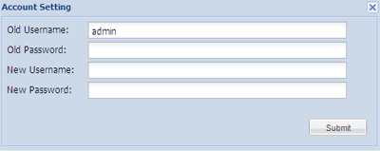

In this Account Setting menu, parents can manually input the old username and password, and input a new username and password for your account to make sure you are the only authorized person has access to SurveilStar Control Center.

4.2 Language Setting

SurveilStar Professional Provide you five languages available for your choice: English, French, German Chinese and Japanese. You can set languages at the top-right corner of control panel. Click "Setting" at the top-right corner, the language setting window will pop up.

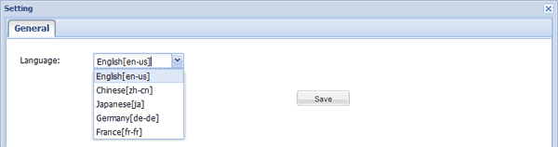

5. Purchase and Register
5.1 Purchase

(1.) Purchase Home Edition (SurveilStar Any Parental Control)
The demo version provides a 15-day trial for monitoring only one computer. Buy licenses to upgrade your SurveilStar Pro now.
License Policy: One license for one computer. If you need to monitor more than one computer, please use our purchase options on the order page.
Payment options: We accept orders via Credit/Debit card (Visa/MasterCard), Bank/Wire transfer, American Express Card, Diners Club Card, JCB Card, PayPal, Credit/Debit card (Payment information by Fax)

You will receive the registration name and code immediately after you finish ordering procedures. (* If you do not receive your code after several hours, please check your spam filtering in case that our registration email gets marked as spam and sorted into a "junk" folder or deleted. Make sure emails from all addresses at anvsoft.com are white-listed. You may also send email to support@surveilstar.com to request that your code be resent to another email account owned by you. )

Once you purchase our product, you will receive:
* A full version of the software without restrictions;
* Comprehensive and priority support;
* Free minor updates and bug fixes.


Volume discount prices
Quantity | Lump Sum
1 | 49.95 USD
3 | 99.95 USD
10 | 199.95 USD

Note: If you need more than 10 licenses, we recommend you buy SurveilStar Enterprise Edition.
Both SurveilStar Employee Monitoring and SurveilStar Professional can monitor screen snapshots, emails, instant messages and website visit. If you want to learn more details about their differences, please check version comparison and feature module comparison tables.

(2.) Purchase Enterprise Edition (SurveilStar Employee Monitoring)

The demo version provides a 30-day trial for monitoring only 5 computers. Buy licenses to upgrade your SurveilStar now.
License Policy: One license for one computer. If you need to monitor 100 computers, you shall purchase a quantity of 100 licenses.
Volume discount prices
Quantity | Unit Price
1 | 69.95 USD
2 - 10 | 64.95 USD
11 - 50 | 59.95 USD
51 - 100 | 54.95 USD
101 - 500 | 49.95 USD
501 - 1000 | 44.95 USD
1001 + | 39.95 USD

If you have any problem about ordering SurveilStar, please send email to support@surveilstar.com.

5.2 Register
Once you receive the license you've purchased, you can follow the steps below to register the program to get the full version.
1. Login SurveilStar Control Center.
2. Go to the upper right windows, and click, and you will be prompted the Setting menu.
3. Click Registration/License tab, and then enter your registration name and code.
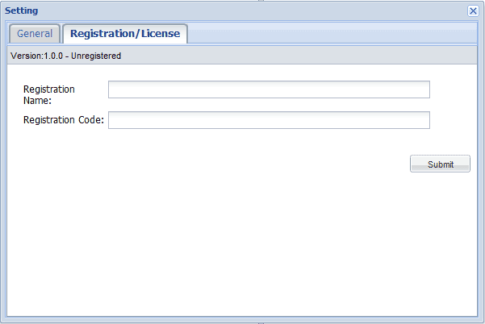
Tips for registration:
You may input the Name and Code manually. The registration name is case sensitive. And, please do not add blank at the beginning or the end of the word. You can also copy and paste the Name and Code into the registration popup dialog.

6. Support
6.1 FAQs

SurveilStar Professional Software Support Center provide you with FAQs, solutions on how to deploy and use Any Parental Control Software, which helps you to record incoming and outgoing mails, web browsing history, transferred files and IM chats.
Ordering FAQ
(1). Once paid how the product is delivered to me?
After your order completes, you will receive an email containing a link to download your software, instructions for installation and your registration info.
(2). Can I move the license to a different computer? If I have a new computer do I need to purchase another license?
Yes, you can move licenses as long as the total number of installations doesn’t exceed purchased license count. Just uninstall the program from one computer and reinstall it on the other one using your existing registration info.
(3). I have lost my registration info. What do I do?
You can get your registration information by using Order locator tool. If you don't see your order then you might have bought the program using a different email address. Please update your email address and try once more. If you still don’t see your registration info, please contact tech support. Please enter your email address used for the purchase in input field and press "Send". Your registration info will be delivered to your personal email account.

Product FAQ
(1). Does SurveilStar Professional software work on Windows 7?
Yes, the latest version of the program works on Windows 7. SurveilStar products work on Microsoft Windows 2000/XP/2003/Vista/7.
(2). I have forgotten my SurveilStar password. What do I do?
If you use a registered version please use your registration key as a password. If you use a trial version please contact tech support at support@surveilstar.com
(3). Will my anti-virus or anti-spyware software block SurveilStar? What do I do if SurveilStar suddenly stops recording?
The antivirus software installed on your computer might conflict with or block SurveilStar Any Web Protection software. We strongly recommend that you add SurveilStar to the exception list.
If the instructions above do not include your particular anti-virus, please exclude SurveilStar according to the documentation of your anti-virus. You will need the list of SurveilStar files. Please contact tech support for this info.
If your anti-spyware product allows excluding files only by file name, do not specify the path.
You may have to reinstall the product afterwards.
(4). Does SurveilStar protect my child from web predators?
SurveilStar allows you to be aware that some unwanted activity has been available to your child.
For example if a pedophile has an online conversation with your child, SurveilStar will record that conversation. If you see that your child has had such a conversation, you will be able to take the appropriate action to stop that from happening in the future. Further, if a pedophile suspects that he/she is being recorded, they will quickly move on to another target or most likely stop going after children.
(5). Will SurveilStar work with applications other than Web Browsers?
Yes. SurveilStar records PC activity for all of your applications, including word processors, spreadsheets, financial programs, databases, communications, and even games. With SurveilStar you'll be able to see exactly how your children or employees are spending their time.
(6). Can SurveilStar be circumvented?
NO. SurveilStar is hidden from users of a monitored computer and is protected from being blocked or uninstalled by unauthorized users.
When all the settings for invisibility are enabled, SurveilStar does not show in Windows system tray, Start menu, Add/Remove Programs, Task Manager. Only IT manager or supervisor with administrator privilege can uninstall SurveilStar monitoring Agent. Unauthorized users cannot uninstall SurveilStar or delete history records.
(7). Does SurveilStar slow down computer?
SurveilStar does not slow down the operation of the computer it is monitoring.

6.2 Contact Us

SurveilStar Professional provides FREE unlimited upgrades, service updates, extended support and more once you purchased. You can upgrade the software when new versions become available if you are a registered user. We also provide free technical support via email to solve any problem you encountered as soon as possible.
So, any problem, please contact us!
Contact us at support@surveilstar.com

